**IDEATION PHASE**

**BRAINSTORM & IDEA PRIORITIZATION**

|  |  |
| --- | --- |
| **Date** | **19 September 2022** |
| **Team ID** | **PNT2022TMID47477** |
| **Project Name** | **IoT based smart crop protection system for agriculture** |
| **Maximum Marks** | **4 Marks** |

**Step:1**

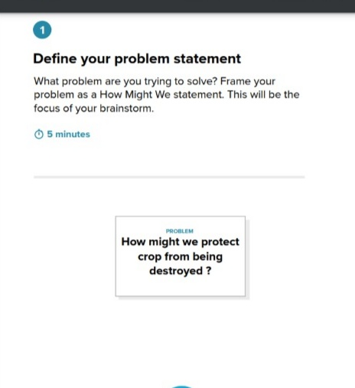

**Step: 2 Brainstorm, Idea Listing & Grouping:**

**BRAINSTORM:**

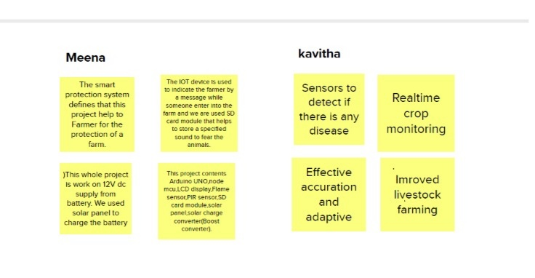

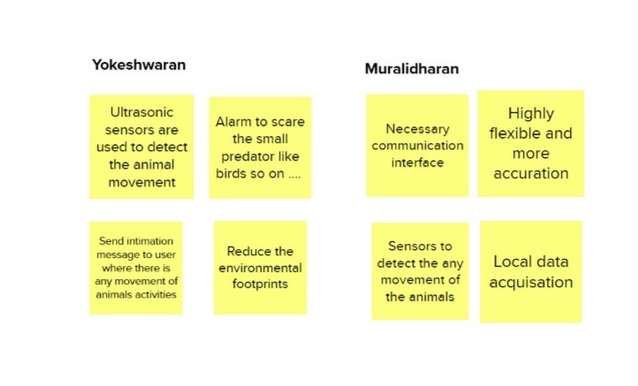

**GROUP IDEAS:**

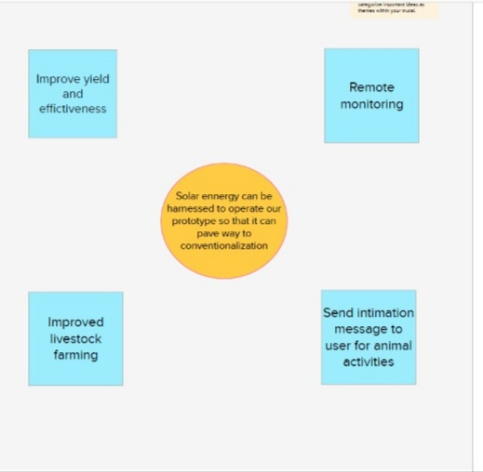

**Step:3**

**IDEA PRIORITIZATION:**

